Game Design Document

1. Story:  
   A hero reaches to the castle of demons to save his princess.
2. Characters:
   1. Hero:  
      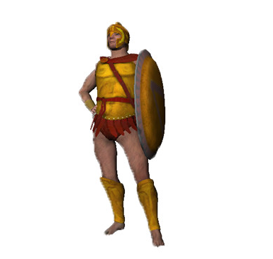
   2. Demons:  
      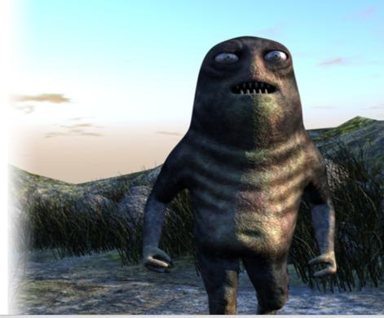
3. Level/environment design
   1. Level:  
      1 level for this version
   2. Environment:
      * Ground: dark, road made by cubes
      * Background: black, mountains, castle (maybe)
      * Other: trees, stones
4. Gameplay:
   1. Goals:
      * Win: the character reaches the end without die
      * Lose: the character dies
   2. Basic Rules:
      * Road: a unique road contains traps
   3. Rules of Hero:
      * Attributes: health, energy, action point
      * Action point: achieved by roll dice(s)  
        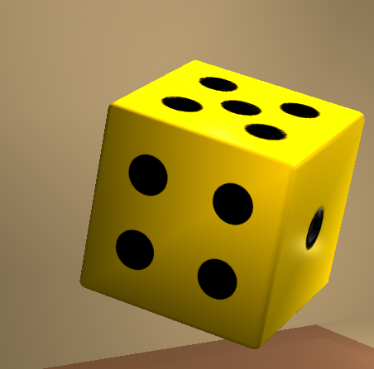
      * Actions: move, attack, resist, spells (maybe)… cost action point
      * Die when losing all health
   4. Rules of Demons:
      * Attributes: health, energy
      * Appear when hero stands one a trap
      * Can attack
      * Die when losing all health
   5. Rules of Explosion trap (not available)
5. Art: (not available)
6. Sound and Music: (not available)
7. User Interface, Game Controls:
   1. User Interface: (not available)
   2. Game Controls:
      * Keyboard:
        + Roll dice: key enter
        + Move: key w
        + Attack: key a